Lab 4: Operational Amplifier Application: Electronic Security System

Design: Part 1 of 2

**Goals for Lab 4 –** In Lab 4 and Lab 5, you will design, build and analyze an electronic security system using an infrared (IR) emitter, a photo detector, operational amplifiers, resistors, a comparator, a latch, and light emitting diodes. The main task is to build a circuit that will detect an interruption in a light beam and trigger an indicator. In the process of designing this system, you will learn to use op-amps to serve various purposes.

**Theory -**The block diagram of the system is shown in Figure 4.1. The stages to be built and tested this week are enclosed in the dashed box. An IR emitter is employed to send a (non-visible) light beam to a photo detector. The photo detector current induced by the light beam depends on the strength of the beam. The first stage in your design will be to build a circuit to convert the current produced by the photo detector to a voltage. We will investigate a few different configurations for achieving this. Since the output of this first stage may be very small, you will design and build an op-amp based amplifier to bring the signal strength up to a usable level. After the voltage is amplified, it will be sent into a comparator which basically decides whether the light beam is present or is being interrupted. In Lab 5, you will build a latch to lock the signal and a system of LEDs to serve as the alarm. In the end, whenever the beam is obstructed, the comparator output will be changed. It will then be locked by a latch circuit and the appropriate LED will light.

Infrared

Emitter

Photo Detector

Current to Voltage Converter

Signal Amplifier

Comparator

Latch

LEDs

Figure 4.1 – Block Diagram of Alarm Circuit

**Operational Amplifiers:** As discussed in class, a typical op-amp has five connections as shown in Figure 4.2: Two inputs, two power supplies, and one output. In the lab, we will use the LM741N op-amp which comes in an eight pin DIP (dual in-line package) integrated circuit (IC). The pin connections for this particular op-amp are also shown in Figure 4.2. Note that there is a small semi-circular notch on one end of the IC so that you can tell which end is pins 1-4 and which end is pins 5-8. You should find and peruse a data sheet online for this op-amp so that you can familiarize yourself with its use. The size and spacing of the pins on the IC have been carefully constructed so that the IC will plug nicely into your breadboard as shown in Figure 4.3. Given the positioning of the two resistors in Figure 4.3, what kind of configuration is being used in this set-up?

+

_

Positive

Power

Supply (7)

Negative

Power

Supply (4)

Inverting

Input (2)

Non-inverting

Input (3)

Output (6)

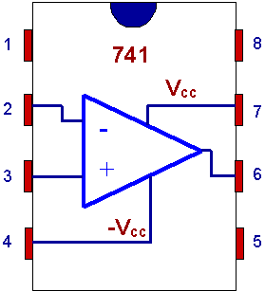

Figure 4.2 – Schematic diagram and pin configuration for the LM741N Op-Amp.

Figure 4.3 – Op-Amp connections on a breadboard.

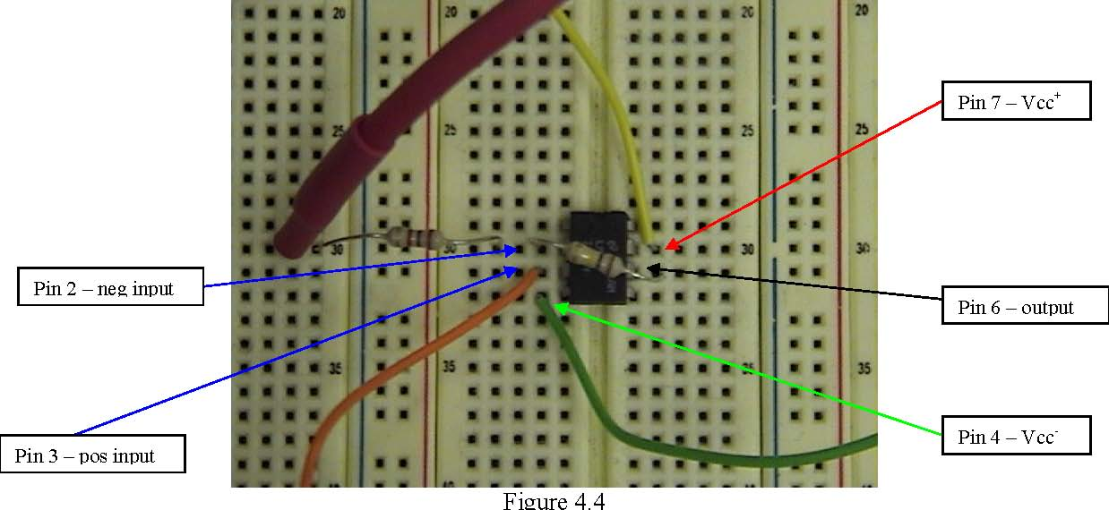

For this course, we will use the ideal op-amp model to help analyze op-amp circuits. Recall the ideal op-amp assumptions and the resulting equations:

**Virtual Short Condition: $v_{p}=v_{n}$** (the voltage on the two inputs will be essentially equal)

**Infinite Input Resistance: $i_{p}=i_{n}=0$** (current into input terminals is essentially zero).

Analysis of op-amp circuits generally starts from these equations. From there we use Ohm’s Law, KVLs, KCLs, etc. until we have determined the currents/voltages we are interested in.

**Specific Use of an Op-Amp: A Comparator**

Figure 4.4 – Op-Amp as a comparator.

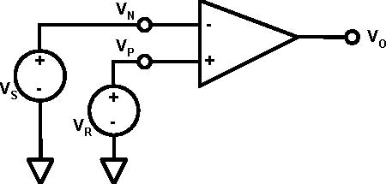

A comparator, as shown in Figure 4.4, compares a signal voltage on one input with a reference voltage on the other input. Without feedback (between the output and the input), an op amp operates in saturation whenever the inputs are not equal. Recall that the gain of the op-amp is very large. If we force different voltages on the input terminals, the op-amp will try to make the output voltage very large, but it cannot create anything larger than the saturation voltage. If the (+) input of an op amp, $v_{p}$, is *above* its (-) input, $v_{n}$, the output voltage, $v_{o}$, is pulled *up* to the positive saturation voltage. If the (+) input of an op amp, $v_{p}$, is *below* its (-) input, $v_{n}$, the output voltage is pulled *down* to the negative saturation voltage. Typically, the saturation voltages are a little less (0.5-1.5 volts) than the supply voltages.

The output of a general purpose op-amp such as the 741 has limitations. Its output changes between the limits fixed by the saturation voltages, +Vsat and –Vsat, that might be something like ±10V for say a ±12V power supply. Therefore, the output cannot drive devices that require typical logic voltage levels 0 and +5V (or, +12V), such as logic integrated circuits or microcontrollers. This problem can be solved by using integrated circuits that have been specifically designed as comparators. One such device is the 319 comparator. This device has 2 comparators in one package. You will use one of them. The pin layout of the device is shown in Figure 4.5. The output of the comparator will be near 0V when the inverting input is larger than the non-inverting input. When the non-inverting input is larger than the inverting input, the output is left floating (that is it looks like a very high resistance connected to ground). Thus by connecting the output to a voltage source through a “pull-up” resistor, we can make the “high” output level to be pretty much anything we like. It doesn’t have to be tied to the positive supply voltage.

Figure 4.5 – The LM319N Comparator



**Prelab –**

1. Analyze the circuit in Figure 4.6.
2. **Find $V_{o}$ as a function of $R$ and $I_{d}$ (assume the op-amp is ideal).**
3. **If $I_{d}$ = 100**µ**A and the desired $V_{o}$ = -0.5V, find the proper value for $R$.**
4. **Verify your result by running a SPICE simulation using the 741 op-amp model. Be sure to display voltages on your schematic.** (SPICE hint: Most students have found the “Universal Op Amp” works best as your op-amp. Pay special attention to your pins as well as the directions of applied voltages. Use separate DC voltage sources which have been grounded for pin 7 and pin 4.)

Figure 4.6 – Current to voltage converter using an op-amp.

-5V

$$I_{d}$$

**+**

**_**

+5V

$$V_{o}$$

$$R$$

1. For the circuit in Figure 4.7, **calculate $V_{r}$** . **Calculate the threshold input voltage, $V_{i}$, that will change the output of the comparator from high to low. Show all calculations and explain your work.**
2. Model the circuit in Figure 4.7 in SPICE for Vi = 2V and Vi = 4V. **Print out a copy of both schematics with voltages displayed to hand in.** Your SPICE simulation and calculations should match.

319

Figure 4.7 – Voltage comparator.

$$10kΩ$$

$$1kΩ$$

$$1kΩ$$

$$2kΩ$$

$$V_{r}$$

$$V_{i}$$

-5V

**+**

**_**

+5V

**+**

**_**

+5V

+5V

**Procedure –**

Required Special Equipment:

* A selection of ¼ W resistors
* 1 – LM319 op-amp comparator
* 2 - LM741 (or equivalent) operational amplifier
* 1 – IR emitter and detector (pair)
* A selection of colored 24 gauge connection wires, at least 10 strands

During this lab, you will familiarize yourself with the various components that we will use to design and build our security system. Once you have a thorough knowledge of how each piece works, you will then design the system during the next lab that will put all the pieces together.

**Task 1 – IR Emitter and Detector**

In this lab, we will be using a simple IR emitter and photo detector shown in Figure 4.8.

Figure 4.8 – IR Emitter and Detector (and an LED)

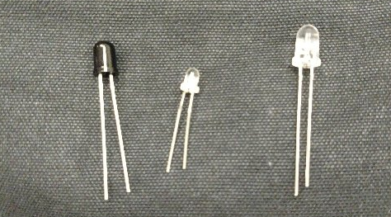

IR Emitter

Photdetector

LED

The emitter is the one with the tinted casing while the detector has the clear casing. (**Note:** The photodetector looks very much like one of the LEDs in your kit. We have shown the LED in the photo in Figure 4.8 as well so that you can tell which is which.) Notice that with both the IR emitter and the detector, one lead is longer than the other. This allows you to keep track of polarity as neither of these devices will function if you hook them up backwards. For the emitter (the dark one), the long lead is the anode (A) and the short lead is the cathode (C). It essentially functions as a diode that emits IR light when there is a current flowing through it. You will have to apply a reverse bias (a positive voltage measured from the cathode to the anode) in order to turn the emitter on. The detector (the clear one) is essentially a photo diode. Current will flow in proportion to the intensity of the IR light incident on it. The photo diode also works in reverse bias mode which means a positive voltage must be applied from the cathode to the anode. Again, the short lead is the cathode (C) and the long lead is the anode (A). When this device is detecting IR light, current will flow from the cathode to the anode.

It is important to get the polarity of both devices correct when you assemble your circuit. Working with the IR devices can be a little tricky since the emitted light is not within the visible spectrum. It can be hard to tell if the emitter is on or not. When the emitter is on, you might be able to see a dim glow if you are in a dark room, but sometimes you may not see anything. However, if you look at the emitter through your cell phone camera, you *may* see it glowing bright purple when the emitter is on (depending on your phone, this does not work with all phones).

First, assemble the emitter using the simple circuit shown in the left of Figure 4.9. The purpose of the resistor is to limit the current so as not to damage the emitter. Since the emitter is rated at a maximum continuous forward current of 100mA, the resistor, $R_{E}$, should be at least $50Ω.$ Measure the voltages across both the resistor and the IR emitter for several different values of $R_{E}$. You should be able to infer the current flowing through the emitter $I_{E}$ from the voltage measured across the resistor. In your lab report, provide a plot of $I_{E}$ vs. $R_{E}$.

**Caution:** Do not place the supply voltage across the emitter without the current limiting resistor in place. This will cause too much current to flow and will burn out your emitter. Therefore, **you must disconnect the supply voltage before you switch out resistors.**

Next assemble the detector circuit as shown on the right in Figure 4.9. The resistor in this circuit is playing a completely different role. As long as there is a sufficient bias voltage across the photo diode, current will flow and the amount of current will be related to the intensity of the IR light incident. The resistor is now converting the current produced by the photo diode to voltage. In the context of Figure 4.1, the resistor $R_{D}$ is the “current to voltage converter.” Measure the voltage, $V_{D}$, for several different values of $R_{D}$. As before, you can infer the current $I_{D}$ from the measured voltage, $V_{D}$. Again, provide a plot of these quantities in your lab report. Make sure to record and note the distance between your emitter and detector that led to these measurements.

Figure 4.9 – Emitter and Detector Circuit

$$R_{E}$$

+5V

Anode (long lead)

Cathode (short lead)

Emitter

$$R_{D}$$

+5V

Cathode (short lead)

Anode (long lead)

Detector

$$V_{D}$$

**+**

$$I_{E}$$

$$I_{D}$$

**_**

**Note:**

1. The emitter and detector are quite directional. You will need to carefully align them so that they are pointing at each other as shown in Figure 4.10. It might be helpful if you put the emitter and detector on two different breadboards (if you and you partner have separate breadboards). This will make it much easier to fiddle with the alignment.

Figure 4.10 – IR Emitter and Detector Alignment

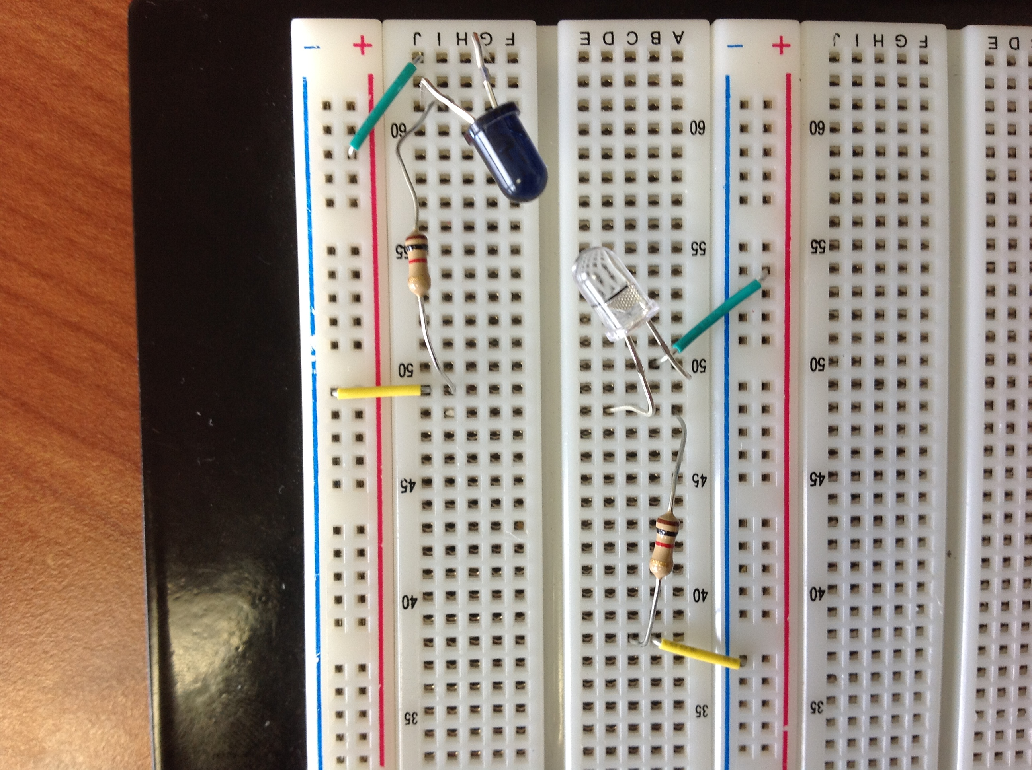

Once you have the emitter and detector circuits functioning properly, you should be able to see the detector voltage, $V_{D}$, fall as you block the path between the emitter and detector. You can use your hand, a credit card, a piece of cardboard or thick paper, etc.

Now it is your turn to experiment. Try playing around with the resistor values, $R_{E}$ and $R_{D}$. Your goal is to get as large of a difference as possible between the detector output voltage when the IR beam is obstructed and when it is unobstructed. Also*, move the emitter and detector as far apart as you can* and still be able to measure different voltages for the two cases. Tell us in your lab report:

* What resistor values did you finally decided upon and why?
* How far apart where you able to place the emitter and detector and still have the circuit function as intended?
* What were the detector voltages that you measured for the obstructed and unobstructed cases (with the pair placed as far apart as you could)?

Finally, consider the op-amp based detector circuit shown in Figure 4.11. Try implementing this circuit for your detector. In your lab report, explain how this is better/worse than the simple resistor we used previously.

741

Figure 4.11 – An Op-amp based detector circuit.

$$R_{D}$$

-5V

**+**

**_**

+5V

+5V

$$V_{D}$$

**+**

**_**

**Task 2 – Signal Voltage Amplifier**

Before we send the detector output voltage to a comparator, it will be helpful to amplify this signal so that there is a substantial difference between the high voltage and the low voltage. Build the inverting amplifier circuit shown in Figure 4.12(a). You can use the +/-5V output on the PMD as the supply voltages. Choose your resistor values so that the circuit provides as much amplification as possible without danger of saturating. Remember, the output of the detector circuit from Task 1 will be the input to this amplifier. Which resistor values did you choose and why? Provide adequate reasoning in your lab report.

With the resistor values you have chosen, measure the output voltage of your amplifier for a range of input voltages. In your lab report, provide a plot of $V_{out}$ vs. $V_{in}$. Make sure your plot clearly shows where saturation occurs (on both the positive and negative side). Are the detector output voltages you encountered in Task 1 within the linear range of the amplifier you designed?

Now repeat this task for the non-inverting amplifier configuration shown in Figure 4.12(b). Again, you should justify the resistor values you have chosen and provide a plot of measured $V_{out}$ vs. $V_{in}$. Which amplifier circuit would couple better with the detector circuit of Task 1? Comment on this in your lab report.

741

741

Figure 4.12 – Op-amp based amplifier circuits.

$$R_{1}$$

$$R_{2}$$

-5V

**+**

**_**

+5V

$$V_{out}$$

**+**

$$V_{in}$$

**_**

**+**

$$R_{3}$$

$$R_{1}$$

$$R_{2}$$

**_**

-5V

**+**

**_**

+5V

$$V_{out}$$

**+**

$$V_{in}$$

**_**

**+**

**_**

1. Inverting Amplifier

(b) Non-Inverting Amplifier

**Task 3 – Comparator**

The last step in this part of the lab will be to use a comparator to change the two output voltages you are reading to standard digital logic levels. Build the circuit shown in Figure 4.13. The two unspecified resistors, $R_{1}$ and $R_{2}$, function as a voltage divider to bring the +5 volts supply down to a proper level to use as the reference voltage for the comparator. Given that the output of the amplifier from the last stage will ultimately provide the input voltage for the comparator, what would be a good level to set your reference voltage at? Choose proper resistors to provide that voltage reference. Once you have chosen your resistors, measure the output voltage of the comparator for several different input levels. Pay particular attention to the region where the output transitions from near 0V to near +5V. How much does the input voltage need to be above the reference to provide the full high level on the output? Similarly, how much does the input voltage need to be below the reference to provide the full low level on the output? For what range of input voltages do you see some kind of “in between” voltage on the output? In your lab report, provide a plot of $v_{o}$ vs. $v_{i}$.

319

Figure 4.13 – Voltage comparator.

$$10kΩ$$

$$1kΩ$$

$$R_{2}$$

$$R_{1}$$

$$V_{r}$$

$$V_{i}$$

-5V

**+**

**_**

+5V

**+**

**_**

+5V

+5V

$$V_{o}$$

Now that you have an understanding of how each of the various components works (i.e., the emitter and detector, the op-amp amplifiers, the comparator), in the next lab, you will put everything together into an overall system design.

**Lab Report**

In your lab report this week, make sure to address each of the following:

*Task 1*

* Provide plots characterizing the operation of the emitter circuit.
* Provide plots characterizing the operation of the detector circuits (both the one in Figure 4.9(b) and the one in Figure 4.11).
* What resistor values did you finally decided upon and why?
* How far apart where you able to place the emitter and detector and still have the circuit function as intended?
* What were the detector voltages that you measured for the obstructed and unobstructed cases (with the pair placed as far apart as you could)?

*Task 2*

* Provide a plot of measured $V_{out}$ vs. $V_{in}$ for both amplification circuits in Figure 4.12. Be sure to indicate what your saturation voltages are.
* Comment on which amplifier circuit would couple better with the detector circuit(s) of Task 1? Why?

*Task 3*

* Discuss what resistance values you chose and why.
* Provide a plot of measured $V_{o}$ vs. $V_{i}$ for the comparator circuit.
* Discuss what the input voltages need to be to cause the output to produce each of the desired logic levels.